**Creation Of NODE-RED Services**

|  |  |
| --- | --- |
| **Team ID** | PNT2022TMID02439 |
| **Project Name** | Project -Smart farmer-IOT enabled smart Farming Application |
| **Team Members Name** | Kamesh Kumar K ,Kaviyaraj C ,  Javeed Akram Z , Kavinsaran JK |

**Step 1:** Login To Your IBM Cloud Account

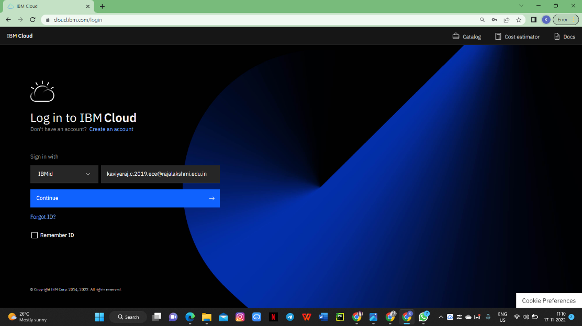

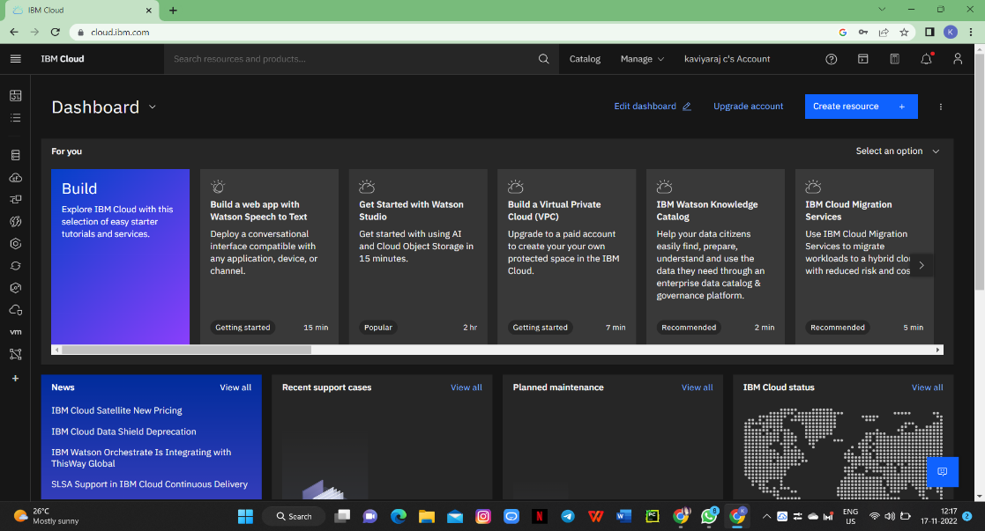

**Step 2:** Click on Resources & Search For NODE-RED APP

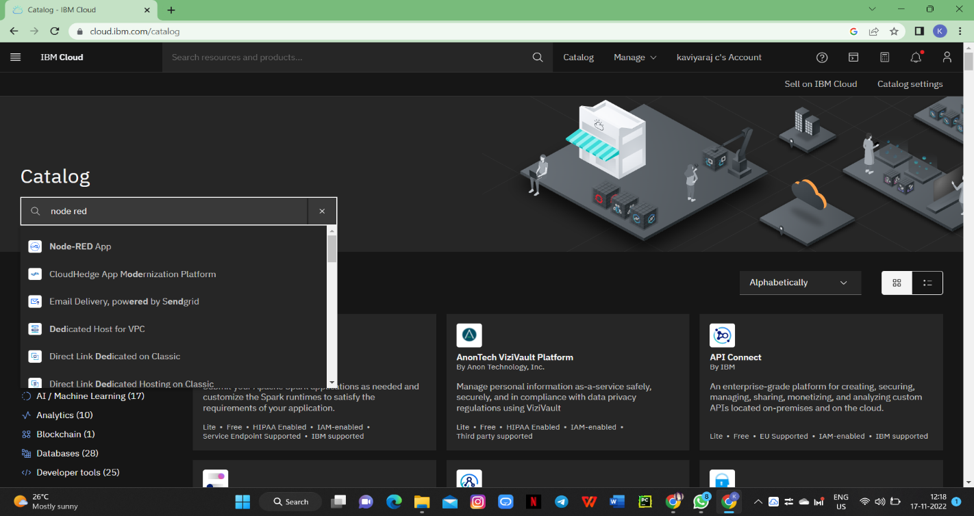

**Step 3:** Once you Created Node-Red Services In Data Base Drop Down

Box Your Node Red Link Will Be Added

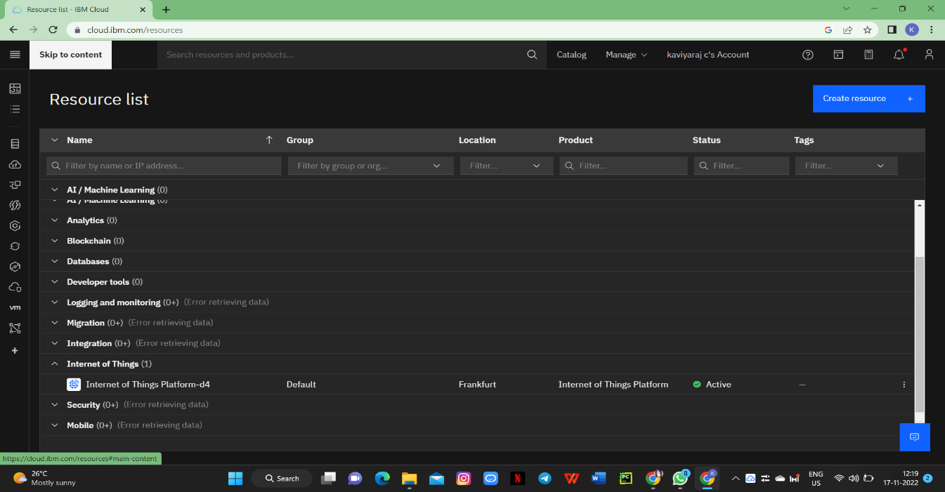

**Step 4:** Click on the Link Your Node Red Will be Opened

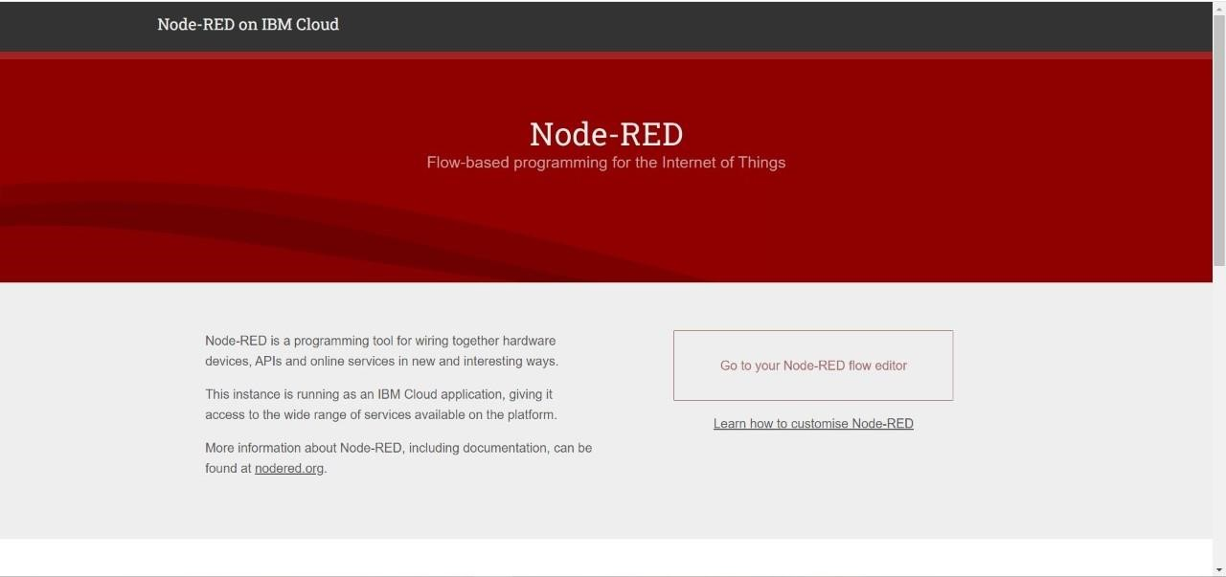

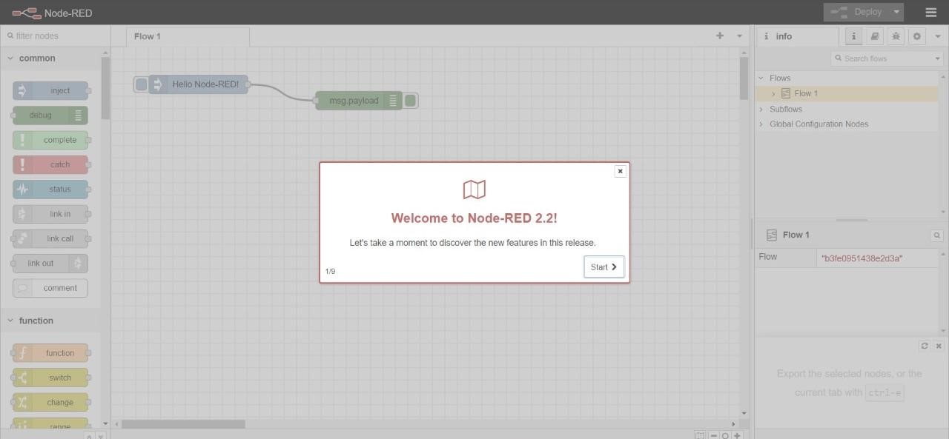

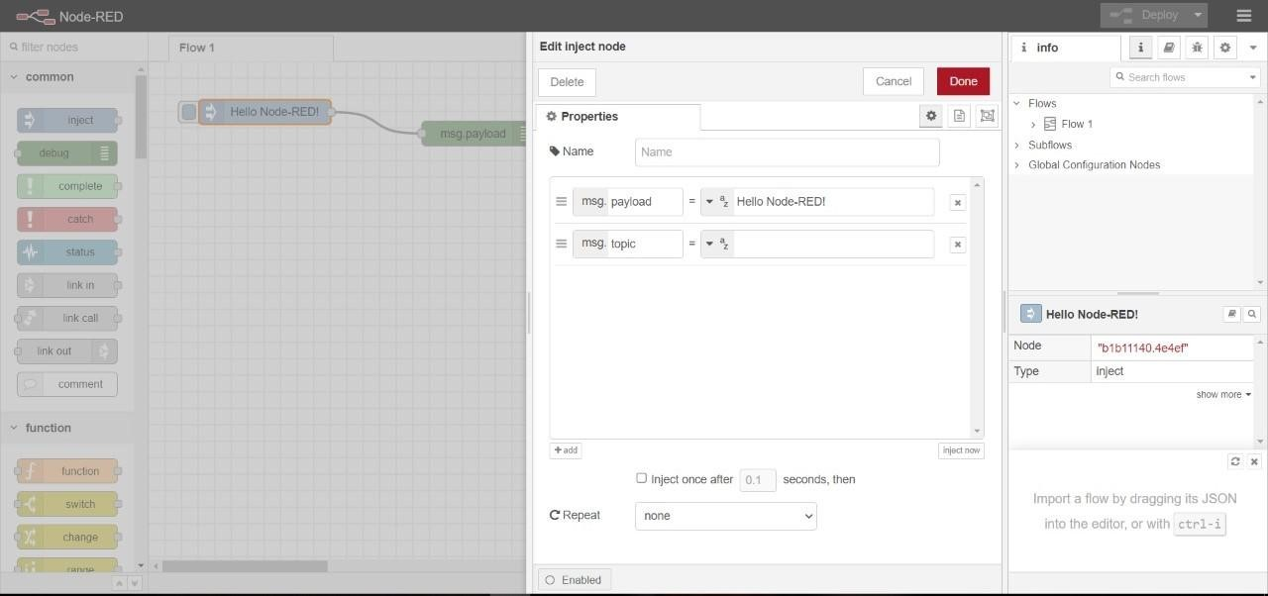**Step 5:** Inject Node and Debug Node will be displayed

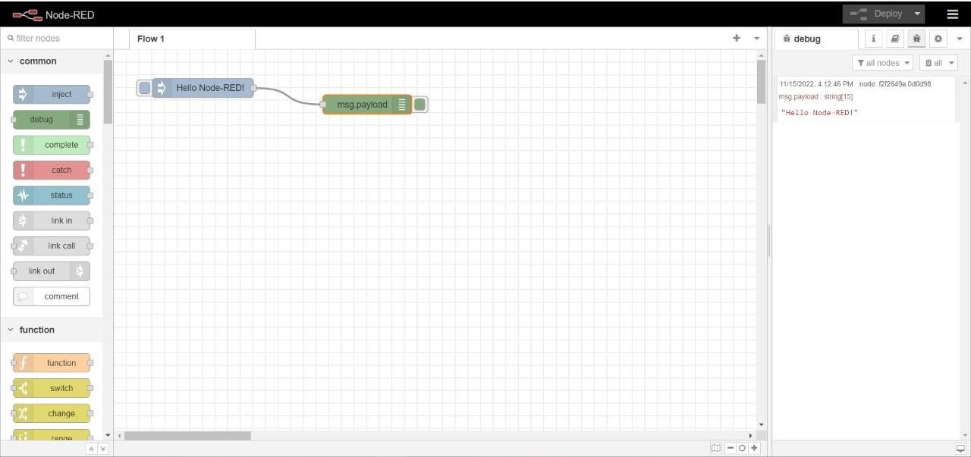

**Step 6:** By double clicking on inject node and debug node it can be edited

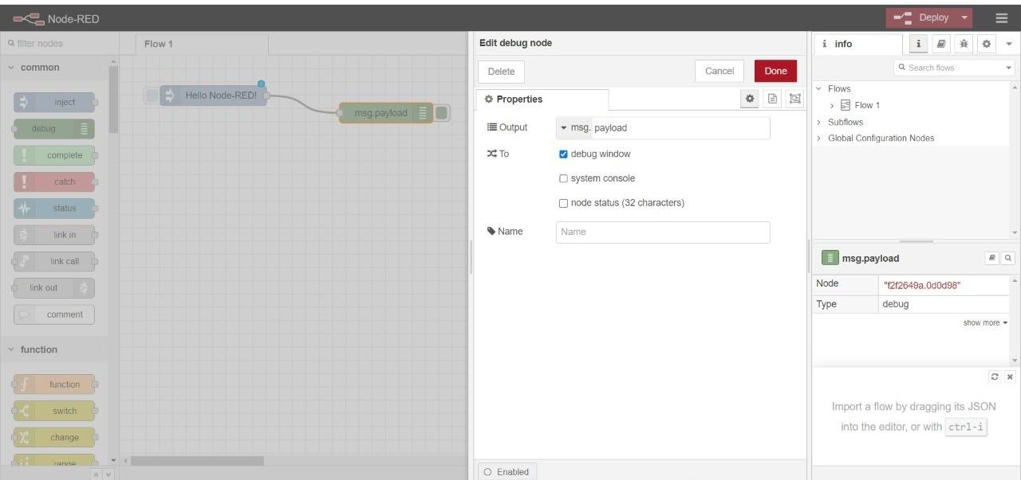

**Step 7:** Click on the Deploy Button,Hello Node red will be printed



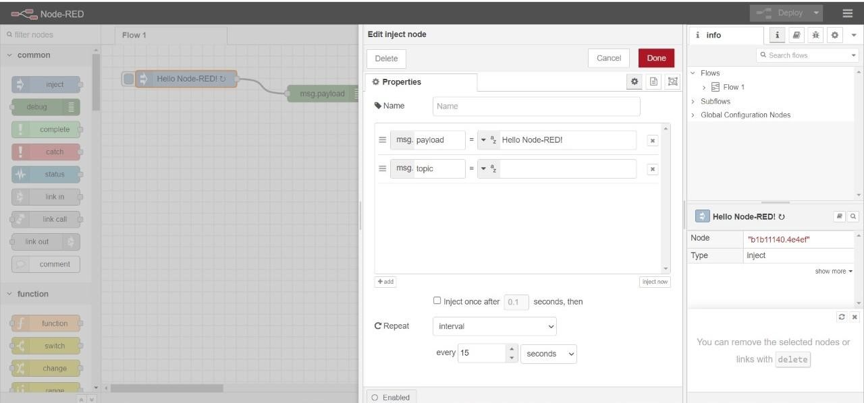**Step 8:**Now set a time interval of 15 seconds in inject node



**Step 9:** Hello Node will be printed for every 15 seconds in debug